CERTIFICATE

confirming participation in VII INTERNATIONAL MUSICAL COMPETITION – Belgrade, Serbia 2016

The competition is organized and held by the Association of pedagogues musical institutions of Serbia and production centre MIR production, with the support of public institutions of culture and communication.

Competitor | Teacher | Discipline | Prize,  Points | Musical institution | City,  Country

International Music Competition (www.musiccompetition.eu) passes completely through the Internet and is the only competition of this kind since its inception.

Competition takes place on 31 nominations (all classical and national instruments- solo, dues, ensembles, orchestras and choirs). In the contest in 2016, was attended by 875 online applications, 30 countries, which is 1167 contestants and 180 cities from 280 schools.

The jury was attended by 75 musicians from 23 countries many of whom are eminent teachers, musicians and artists who teach at prestigious music institutions are soloists and play in the top 10 best orchestras and opera houses.

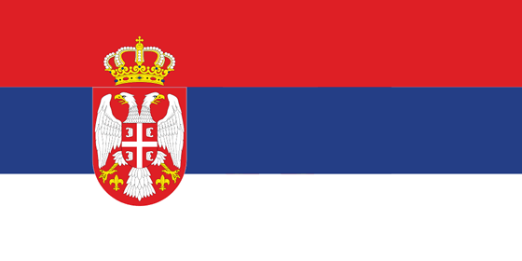 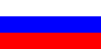 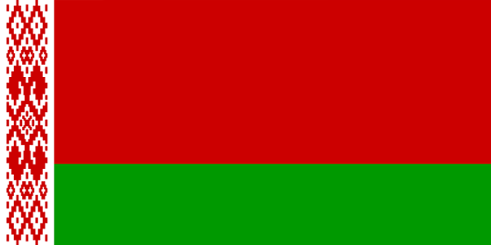 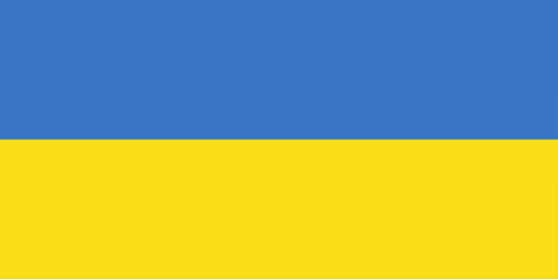 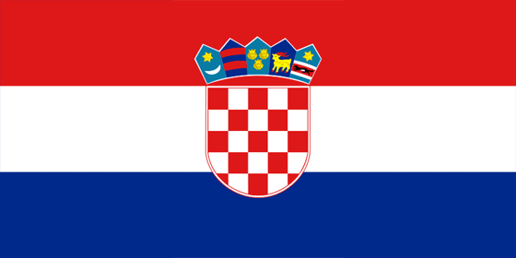 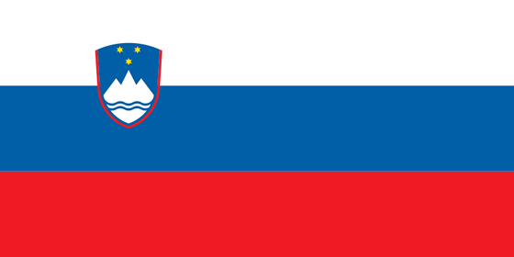 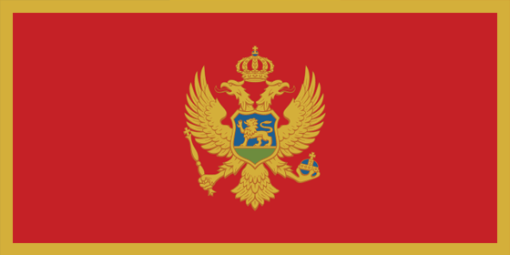 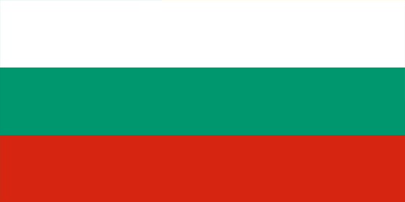 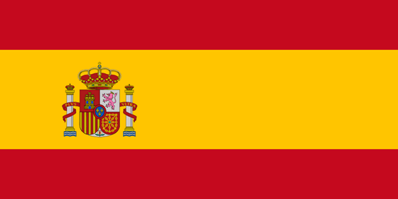 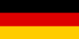 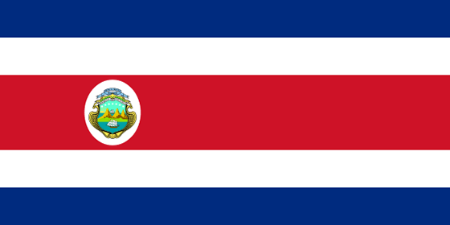 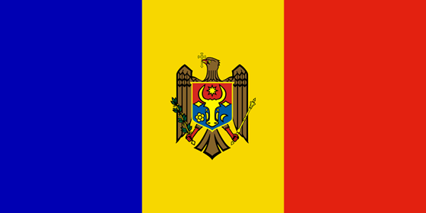 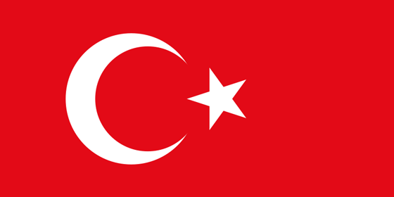 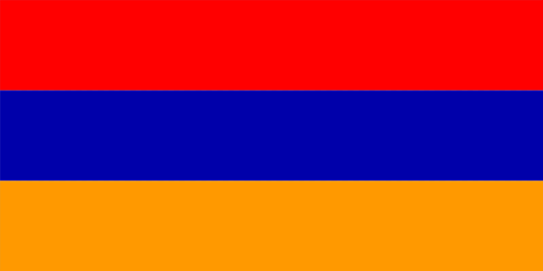 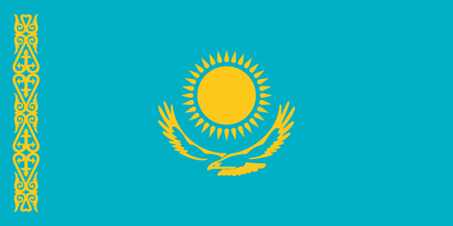 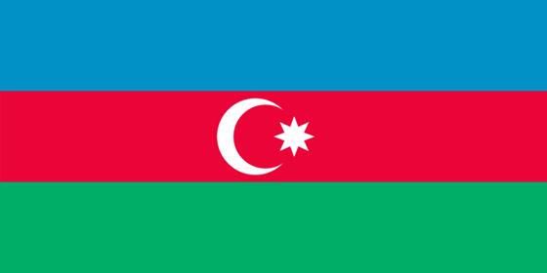 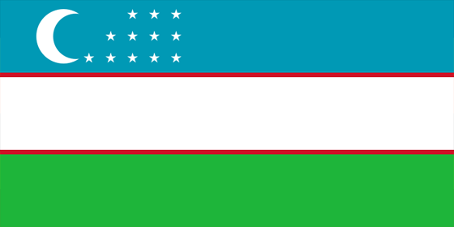 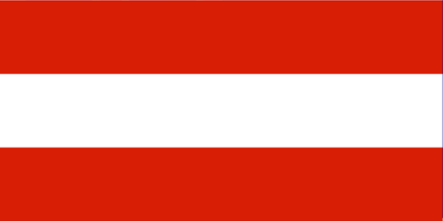 …

Serbia, Russia, Belorussia, Ukraine, Croatia, Slovenia, Montenegro, Macedonia, Bulgary, Spain, Slovakia, Belgium, Germany, Poland, Estonia, Costa Rica, Moldavia, Turkey, China, Armenia, Romania, Kazakhstan, Azerbaijan, Uzbekistan, Bosnia and Herzegovina, Austria, Mongolia, Norway, Italy, South Korea

This certificate is for (first name and last of the teacher)
and confirms the participation in
VII International Music Competition
Belgrade, Serbia 2016

Serbia, Belgrade, President of Association
May 9, 2016 Milomir Dojcinovic

